2.5" External SATA Hard Disk ENCLOSURE

Simply Add Your Own 2.5" Hard Disk
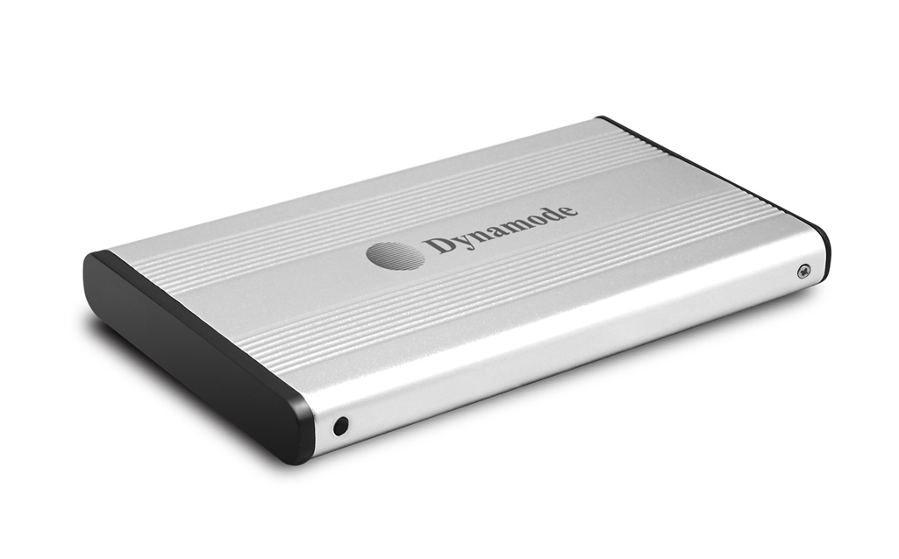

DESCRIPTION
The stylish USB-HD2.5S features a high quality aluminium Enclosure with silent operation, ideal for your existing 2.5" SATA interfaced hard disk drives.

FEATURES
> Stylish and portable aluminum design
> Ideal for your existing 2.5" SATA interfaced hard disk drives
> Re-use your laptop hard disk and keep your data when you upgrade
> Plug n' Play for popular Operating Systems - no drivers needed
> Powered by supplied USB2.0 cable -
no separate power supply required
> Backup and restore your data at up to 480Mbps

SPECIFICATIONS
Transfer interface: USB2.0
Transfer data: 480Mbps(MAX)
Hard disk type: 2.5" SATA interfaced hard disk
Working temperature: -40 ~ 65℃
Working humidity: 8% ~ 90%
Storage humidity: 5% ~ 95%
Operating systems: Windows98/ME/2000/XP/VISTA/7/8/10, Mac OS 8.6 or above

